Meet soni
Assignment module 4: Troubleshooting and Helpdesk
Section 1: Multiple Choice
1. What is the first step in the troubleshooting process?
a) Implementing a solution
b) Identifying the problem
c) Testing the solution
d) Documenting the solution
ANSWER= b) Identifying the problem
2. Which of the following tools is commonly used to diagnose hardware issues by testing electrical connections?
a) Loopback plug
b) Toner probe
c) Multimeter
d) Cable tester
ANSWER= c) Multimeter
3. Which Windows utility can be used to view system logs, monitor performance, and diagnose hardware and software issues?
a) Task Manager
b) Device Manager
c) Event Viewer
d) Control Panel
ANSWER= c) Event Viewer

Section 2: True or False
4. True or False: Safe Mode is a diagnostic mode in Windows that loads only essential system services and drivers, allowing users to troubleshoot and fix problems with the operating system.
ANSWER= True

5. True or False: A system restore point is a snapshot of the computer's system files, registry, and configuration settings at a specific point in time, which can be used to revert the system to a previous state if problems occur
ANSWER= True
Section 3: Short Answer
7. Describe the steps involved in troubleshooting a computer that fails to boot into the operating system.
ANS= 1. Check Power and Connections
• Ensure the power cable is securely plugged in.
• Confirm the power supply switch is ON.
• Look for signs of life: fans spinning, lights on, beeps.
2. Listen for Beep Codes (if any)
• Beep codes from the motherboard can indicate hardware issues (e.g., RAM or GPU failure).
• Refer to the motherboard manual to decode them.
3. Check Display Output
• Make sure the monitor is powered on and connected properly.
• Try another monitor or cable to rule out display issues.
4. Disconnect External Devices
• Remove USB drives, external hard disks, or peripherals.
• A faulty or bootable USB device can interfere with startup.
5. Enter BIOS/UEFI
• Press Del, F2, or Esc during startup to access BIOS.
• Check if the hard drive is detected.
• Ensure the correct boot device is selected.
6. Boot into Safe Mode (if possible)
• Press F8 or hold Shift + Restart to access recovery options.
• Choose Safe Mode to load minimal drivers and troubleshoot software issues.
7. Use Startup Repair
• Boot from a Windows installation USB/DVD.
• Select Repair your computer > Troubleshoot > Startup Repair.
• This tool can fix corrupted boot files.
8. Run System Restore
• From the recovery environment, choose System Restore to revert to a previous working state.
9. Check for Hardware Issues
• Reseat RAM and storage drives.
• Test with known-good components if available.
10. Reinstall the Operating System (Last Resort)
• If all else fails, back up data (if possible) and perform a clean OS installation.
Section 4: Practical Application
8. Demonstrate how to troubleshoot network connectivity issues on a Windows computer using the ipconfig command.
ANS= Step 1: Open Command Prompt
- Press Windows + R, type cmd, and hit Enter.
- You’ll see a black terminal window — this is where you’ll run ipconfig.
- Step 2: Check IP Configuration

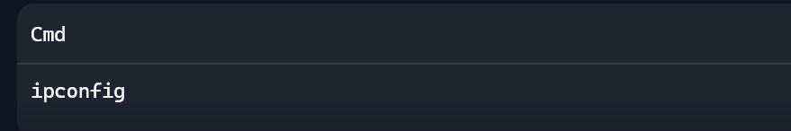
This displays:
• IPv4 Address: Your computer’s local IP.
• Subnet Mask: Defines your network range.
• Default Gateway: The router’s IP — needed for internet access.
Step 3: Release and Renew IP Address
If you suspect a bad IP assignment, type:
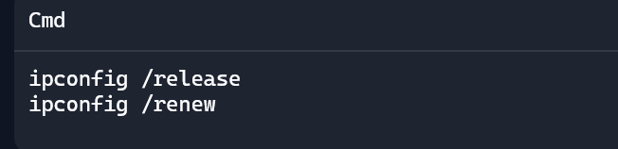
Step 4: Flush DNS Cache
If websites aren’t loading properly, flush the DNS cache:
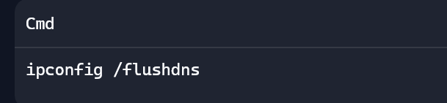
Step 5: Verify Gateway and Connectivity

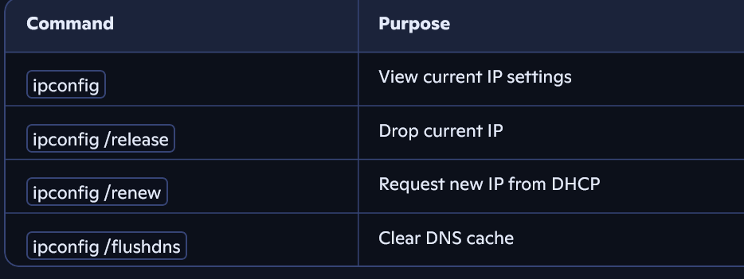
Section 5: Essay
9. Discuss the importance of effective communication skills in a helpdesk or technical support role.
ANS= Why Communication Skills Matter in Tech Support
In helpdesk and technical support roles, you're not just solving technical problems — you're helping people. That means your ability to communicate is just as important as your technical knowledge. Here’s why:
1. Clear Problem Identification
• Users often describe issues vaguely or emotionally.
• Strong communication helps you ask the right questions, interpret symptoms, and pinpoint the real problem.
2. Building Trust and Rapport
• Friendly, respectful communication reassures users, especially when they’re frustrated or anxious.
• It creates a positive support experience and encourages users to return for help when needed.
3. Explaining Solutions Simply
• Not all users are tech-savvy.
• You must translate complex technical fixes into simple, actionable steps without jargon.
4. Reducing Errors and Misunderstandings
• Precise instructions and confirmations prevent miscommunication.
• This saves time and avoids repeated support calls.
5. Handling Difficult Situations Gracefully
• When users are upset or systems fail, calm and empathetic communication can de-escalate tension.
• It shows professionalism and emotional intelligence.
6. Documentation and Handoffs
• Writing clear notes and summaries ensures smooth transitions between support agents.
• It helps maintain continuity and speeds up future troubleshooting.

Examples of KEY Communication Skills
